Southern California Bight Regional Monitoring Program Eelgrass Survey Workplan

Table of Contents

Table of Figures….…………………………………….………………………………………...3
Table of Tables………………………………………….……………………………………….4
Introduction…………………………………….………..…..……………….…………………..5
Approach…………………………………….………………….……………….……………….5
Assessing Condition…………………………….………...…..……………….…………6
Sampling Design………………………………….….…………..……………….………6
Method Harmonization………………………………….………………………………..7
Data Portal and Visualization…………………………………..…………………………7
Overview………………………………………………………………………………………….8
Collecting Eelgrass Data………………………………………………………..……………….10
Field Plan SOPs………………………………….…………..…………………………..11
Site Selection & Reconnoitering…………………………………………...…….11
Dive Planning & Field Preparation……………………………………………....12
Mapping & Perimeter Measurement………………………………………..……13
Sample Design Planning……………………………………………………..…..15
Logger Deployment……………………………………………………………...18
Transect Deployment……………………………………………………….……19
Observational Quadrat Surveys………………………………………………….21
Above Ground & Below Ground Eelgrass Collection……………………...……23
Sediment Collections………………………………………………………….…24
Infauna Collection……………………………………………………………….24
Field Debriefing………………………………………………………………….25
Lab Plan SOPs…………………………………………………………………………...26
Sample Sorting & Preparation…………………………………………………...26
Shoot Count……………………………………………………………………...28
Leaves per Shoot…………………………………………………………………28
Epiphyte Biomass………………………………………………………………28
Shoot Height & Width……………………………………………...…………..29
Leaf Area……………………………………………………………….………30
Above Ground Biomass……………………………………………………..….31
Below Ground Biomass………………………………………………………...31
Sediment Grain-Size……………………………………………………………32
Total Organic Carbon (TOC) and Total Nitrogen (TN)………………………..33
Infauna Analysis………………………………………………………………...33
Sample Storage & Disposal……………………………………………………..35
eDNA Collection………………………………………………………………...35
Literature Cited………………………………………………………………………………….36
Appendix A: Sampling Maps…………………………………….…………..………………….38

Table of Figures
Figure 1. Surface support personnel………………………………………………………..….14
Figure 2. Conceptual diagram of measurements in an ideal eelgrass bed………………….….16
Figure 3. Conceptual diagram of the small patch sampling scheme…………………………..16
Figure 4. Conceptual diagram of the large meadow sampling scheme…………………….….17
Figure 5. Conceptual diagram of the narrow bed sampling scheme………………………..….17
Figure 6. Conceptual diagram of the narrow fringe sampling scheme………………………...18
Figure 7. Illustration of example deployment of light and temperature loggers……………….19
Figure 8. Diagram of shoot height measurement………………………………………………22
Figure 9. Picture of eelgrass measurement of number of shoots and shoot height………….…29
Figure 10. Picture of eegrass width measurement………………………………….…………..30

Table of Tables
Table 1. Eelgrass structure to function relationships…………………………………………..…8
Table 2. Eelgrass plant- and bed-scale metrics…………………………………………….……..9
Table 3. Other environmental measures…………………………………………………………10
Table 4. List of equipment……………………………………………………………………….11
Table 5. Schematic summary of measurements/samples………………………………………..20

Introduction
The 2023 Southern California Bight Regional Monitoring Program (the Bight Program or Bight 23) is a multi-agency monitoring program designed to assess condition the coastal and near-shore ecosystems of the Southern California Bight region. This regional monitoring program is built upon collaborative monitoring efforts over the last thirty years – beginning with the first pilot survey in 1994 and repeating every five years from 1998 through 2023. The goal of the Bight Program is to understand local and regional-scale human impacts on the coastal zone and nearshore oceanic ecosystems – from the intertidal estuarine marsh systems out to the continental slope and the overlying pelagic waters. The 2023 survey covers the Southern California Bight, from Point Conception, CA in the north to the US-Mexico border in the south, while extending out to the waters around the Channel Islands in the west. The 2023 survey has six elements: Sediment Quality, Trash and Microplastics, Ocean Acidification, Shellfish Contaminants, Estuarine Wetlands, and Submerged Aquatic Vegetation.
Bight 23 is the first survey to include an element focused on Submerged Aquatic Vegetation (SAV). The Bight 23 SAV element is specifically focused on the condition of the region’s eelgrass (Zostera spp.) habitats. Eelgrass is the region’s most common type of SAV in estuaries, embayments, and the soft sediment of the shallow coastal zone. Moreover, there is a keen interest in the region’s coastal zone managers in understanding the health and condition of eelgrass in their waters.
Eelgrass plays an important role in the ecology of coastal systems, as it provides unique structure and enhancement of biogeochemical processes. Eelgrass can form expansive beds or meadows in the shallow, soft sediments that serve as temporary refuge from predators, enhance carbon and nitrogen cycling, and serve as a productivity hot spot for commercially and societally important fauna, as well as protected species like sea turtles.
Understanding the health and condition of individual eelgrass beds and how they compare to the health and condition of the region as a whole is important knowledge for the management community. Quantifying the condition and ecosystem functions of individual eelgrass beds is a central tenant of the California Eelgrass Mitigation Policy. Furthermore, eelgrass has been designated as Essential Fish Habitat for managed and threatened species (NOAA National Marine Fisheries Service 2014). Lastly, eelgrass beds are a conspicuous part of the complex mosaic of habitats within estuaries and embayments. Consequently, regulators are interested in using information on their health as a way to make the assessment of the Estuary beneficial use and Sediment Quality Objectives (SQO) more robust (United States Environmental Protection Agency 2010; California Regional Water Quality Conrol Board San Diego Region 2020).
The role of this document is to present the agreed upon field, laboratory, and data management procedures for eelgrass monitoring under the auspices of the Bight 23 SAV monitoring element. Details are provided on collecting eelgrass measurements and samples from the field, processing samples to produce data, and submitting those data to assess the condition of a given bed. This methodology was conceived and field-tested as a part of SCCWRP’s ongoing development of a condition assessment framework for submerged aquatic vegetation (SAV) in California that is focused on interpreting SAV condition from the perspective of a bed’s ability to support its natural ecological functions (McCune et al. 2020).

Approach
The single research question motivating the Bight 23 SAV Monitoring Element is What is the condition of the region’s eelgrass beds? In answering this question, we hope to achieve three goals: 1. Harmonize field and lab methodologies among the disparate groups working with eelgrass in the region; 2. Develop a data storage and visualization tool for eelgrass monitoring data collected as part of Bight or other monitoring efforts going forward; 3. Provide a regional assessment of eelgrass bed condition in estuaries and embayments.

Assessing Condition
Assessing the condition of eelgrass beds is a more complex undertaking than other kinds of bioassessment. Eelgrass, like many other “habitat engineering” flora and fauna (e.g., Wright and Jones 2006; Jones et al. 1994), have a dual nature, both as semipermanent biological resources, whose condition can be indicative of ecosystem health and integrity, as well as a unique habitat that facilitates or enhances novel food webs and biogeochemical cycling that are absent from adjacent habitats in shallow coastal waters. In an attempt to capture both aspects eelgrass beds, we are applying the monitoring framework set out by McCune et al. (2020) that was designed to interpret eelgrass condition through the lens of the ecosystem services and functions a healthy eelgrass bed should provide the coastal ecosystem. This assessment framework is centered around how eelgrass bed functions and services highlighted by technical experts and the management community: Carbon Sequestration, Improvement of Water Quality, Nekton Habitat, Primary Production, Secondary Production, Substrate Stabilization, and Waterfowl Habitat.
Direct measurement of ecosystem functions and services is not a practical approach for a regional monitoring program due to the complexity and time commitments needed to accurately capture rate processes in the field. Accordingly, McCune et al. (2020) created conceptual models combining different structural measures of eelgrass plants and beds that are typically collected into proxies for the key functions (Table 1). The underlying structural metrics that are recommended for collection, as well as the associated methods of collection, are based upon recommendations from a panel of technical experts and managers focused on eelgrass.
Attendant with the field and lab methodology, we also provide quality assurance and quality control recommendations where applicable. However, given the relative newness of this type of standardized data collection, we have yet to amass enough data to fully characterize the natural variance in all of the different metrics. Consequently, we do not provide quantitative data quality objectives (DQO) for most of the data types collected. For more established data types (e.g., macrobenthic infauna composition) DQO targets are suggested along with the QA/QC recommendations. As surveys of eelgrass condition using a standardized suite of techniques and data types increase in frequency, we anticipate eventually being able to create quantitatively informed DQO guidelines in future iterations of this document.

Sample Design
Sample locations for the Bight 23 Eelgrass survey will be selected using a probabilistic design, similar to other Bight monitoring elements. The sampling domain covers estuaries and embayments located between Point Conception, CA and the US-Mexico border. A base map of eelgrass observations within the estuaries and embayments of the region was created by integrating eelgrass maps created by committee members and their institutes over the last 10 years (eelgrass base map). The region’s embayments were stratified in three categories to help ensure even distribution of sample points across the different locations where eelgrass may be found in the Southern California Bight:
- Estuaries – discrete, largely enclosed embayments that connect fully marine waters with freshwater streams or rivers. Typically with a gradient in salinity between the fresh and marine waters (e.g., Anaheim Bay, Batiquitos Lagoon).
- Small embayments – discrete or semi-discrete, relatively open embayments that have open exchange to the ocean, but with no consistent, natural connections to freshwater inputs (e.g., Newport Back Bay, Marina del Rey).
- Large embayments – large open embayments that have open exchange to the ocean, but no consistent connections to freshwater inputs (e.g., San Diego Bay, Lower Newport Bay).
Ten target sample points, as well as associated overdraw sample points, will be selected from each stratum using a random tessellated design (e.g., Larsen et al. 2008; Olsen and Peck 2008) in the R package spsurvey v5.5.1 (Dumelle et al 2023).

Condition Assessment
Eelgrass condition will be quantified using the framework outlined in McCune et al. (2020) and refined by the SCCWRP Regional Eelgrass Survey of Condition and Quality (RESCQ) project (Gillett unpublished). The index is still in development and robust calibration of the index will be made possible by inclusion of the data collected during the Bight 23 Survey. However, the basic design of the index is that eelgrass structural metrics will be combined as indicated in Table 1 to provide as assessment of each function relative to regional standards. The different function-specific assessments will then be combined to provide an overall assessment of eelgrass bed condition (Gillett unpublished).

Method Harmonization
Harmonization of methodology will be achieved, in part, through field crews participating in training and intercalibration exercises. Nearly all of the structural metrics that are being collected are part of “normal” eelgrass monitoring programs. However, small differences in methodology do exist between different practitioners. Through disbursement of the protocols contained in this workplan and participation in field intercalibration exercises, a uniform protocol for assessing the condition of eelgrass beds for the Bight 23 Eelgrass Survey will be created. Field notes and bed-to-bed data will be reviewed by the Bight 23 Eelgrass Survey co-chairs to help identify potential anomalies. These flagged data will be reviewed by the whole committee, including the field or lab crews that produced the data. Furthermore, it is our hope that these specific protocols will find regular usage by agencies and universities that study eelgrass outside of Bight Surveys.

Data Portal and Visualization
Development of a publicly available data storage location with visualization and analysis tools will be done in concert with SCCWRP’s ongoing Regional Eelgrass Survey of Condition and Quality (RESCQ). Data quality checkers are being designed to ensure submission of complete, correctly formatted, and high-quality data (eelgrass data checker). Standardized data query and data visualizations providing regional summaries of overall condition and component assessments function. Analyses of individual eelgrass beds in the context of regional patterns, with respect to induvial structural metrics and conditional assessment scores, will also be provided. Furthermore, the data portal will provide participants the ability to download data to conduct their own analyses.

Table 1 Eelgrass structure-function relationships that will be evaluated as part of the Bight 23 SAV Survey. The intersections highlight the perceived strength of the relationships between the structural metrics and the different functions based upon the SAV expert panel in McCune et al. (2020). Empty cells imply no relationship. Modified from McCune et al. (2020).
 |  |  |  | Ecosystem Services or Functions
 |  |  |  | Carbon Sequestration |  | Improvement of Water Quality |  | Nekton Habitat |  | Primary Production |  | Secondary Production |  | Substrate Stabilization |  | Waterfowl Habitat
 |  | Structural Metrics | Above ground biomass |  | Medium |  | Medium |  |  |  | Strong |  | Strong
 |  |  | Above ground C and N content |  |  |  |  |  |  |  | Medium |  | Medium
 |  |  | Below ground biomass |  | Medium |  |  |  |  |  | Medium |  | Medium |  | Medium
 |  |  | Below ground C and N content |  |  |  |  |  |  |  | Weak
 |  |  | Patch area |  | Medium |  |  |  |  |  |  |  |  |  | Strong |  | Strong
 |  |  | Area to perimeter ratio |  |  |  |  |  | Medium
 |  |  | Percent cover |  |  |  | Weak |  | Strong
 |  | Shoot density |  |  |  | Strong |  | Strong |  | Strong |  | Strong |  | Strong
 |  |  | Leave per shoot |  |  |  |  |  |  |  | Strong |  | Strong
 |  |  | Flowering shoot density |  |  |  |  |  |  |  | Strong
 |  |  | Shoot height |  |  |  | Strong |  |  |  |  |  | Strong |  | Medium |  | Strong
 |  |  | Leaf area |  |  |  | Strong |  | Strong |  | Strong |  |  |  | Medium
 |  |  | Epiphyte biomass |  |  |  |  |  | Strong |  | Strong |  | Strong
 |  |  | Infauna diversity |  |  |  |  |  | Medium |  |  |  | Medium
 |  |  | Infauna biomass |  |  |  |  |  |  |  |  |  | Strong

Overview
This document describes a sequence of events to be done in sampling an individual eelgrass bed. Beginning with reconnoitering the sites, collecting field measurements, collecting samples for laboratory analysis, and conducting laboratory analyses. The instructions have been composed for sampling subtidal beds, though presumably the methods could be adjusted for sampling intertidal eelgrass beds. Furthermore, the primary instructions are constructed to work within the context of a regional-scale, randomly selected sampling scheme. It is assumed that field crews will consist of three people (two underwater and one as surface support). Smaller beds can be sampled by a two-person field crew, as can larger beds if time is available. Conversely, sampling crews greater than three people working together may expedite the sampling of larger beds.
The primary description of each step is framed around the assumption of the sample site being a discrete/semi-discrete eelgrass bed oriented along the shoreline; between 10 - 50m long (parallel to shore) and 5 - 20m wide (shallow to deep). Suggestions for altering certain parts of the protocols to better fit smaller patches of eelgrass or larger meadows of eelgrass are provided. However, in these scenarios some degree of judgement on the part of the field crews will be required. Site-to-site variability highlights the importance of site reconnoitering prior to sampling, which should allow field crews to discuss potential method adjustments with the project leader to ensure all parties on the same page. The field- and lab-based measurements to be made are listed in Table 2. Additional data and samples that could be collected are listed in Table 3.
Table 2 Eelgrass plant and bed-scale metrics to be measured as part of this protocol and which step details their collection.
Metric | Field or Lab Data Generation | SOP Step
Above Ground Biomass | Lab | Step 19
Above Ground C & N | Lab | Step 21
Bed Perimeter | Field | Step 4
Bed Area:Perimeter | Field | Step 4
Below Ground Biomass | Lab | Step 19
Below Ground C & N | Lab | Step 21
Epiphyte Biomass | Lab | Step 16
Leaf Area | Lab | Step 18
Leaves per Shoot | Lab | Step 17
Infauna Diversity# | Lab | Step 22-2
Infauna Biomass# | Lab | Step 22-3
Percent Cover | Field | Step 7-3
Sediment Grainsize | Lab | Step 20
Sediment C & N | Lab | Step 21
Shoot Density | Field and Lab | Steps 7-4 & 14
Shoot Height | Field and Lab | Steps 7-5 & 15
# - Based on committee discussion, infauna metrics will be optional for Bight 23 survey

Table 3. Other environmental measures that could be collected during sampling of the eelgrass beds, but whose methods are not detailed in this SOP. Many measures are not required, but would be useful in different programs depending on their goals and capacity. A diurnal frequency of measure implies multiple measurements taken per day across a spring-neap tidal cycle. This is not meant to be an exhaustive list of additional measures one may collect.
Measurements | Optional / Required | Frequency of Measure
Bed Depth | Required | Multiple Points
Dissolved Oxygen | Optional | Point or Diurnal
Irradiance | Optional | Point or Diurnal
pH | Optional | Point or Diurnal
Salinity | Required | Point or Diurnal
3 Finger Horizontal Water Clarity | Required | Point
Water Column chl a | Optional | Point
Water Column eDNA | Optional | Point
Water Column nutrients | Optional | Point
Water Temperature | Required | Point or Diurnal

Collecting Eelgrass Data
This section details a step-by-step procedure of our recommended methodology used in a complete sampling event for monitoring and assessment of eelgrass beds in southern California estuaries. Steps of the procedure are ordered in sequence of events from initial recon of sampling sites to laboratory analytical procedures. An order of events will help to guide users toward a general timeframe for each event. Collection and analysis of these data will require specific equipment and software, partially listed in Table 4.

Table 4. List of equipment needed to collect the eelgrass data as detailed in this SOP. Note that consumables (plastic bags, jars, etc.) and personal equipment (dive bags, etc.) are both included.
Equipment | Type of Use | Associated SOP Step
0.0625 m² Quadrat | Field | Step 7
0.25 m² Quadrat | Field | Step 7
2-cm X 6-cm Sediment Corer | Field | Step 9
10-cm diameter ring | Field | Step 8 and 9
10-cm X 15-cm Sediment Corer | Field | Steps 9 & 10
63- µm Sieve  500-µm Sieve | Lab  Field/Lab | Steps 15  Steps 10, 22
1-mm Sieve | Lab | Step 18
Area Meter / Bed Scanner | Lab | Step 17
Calipers or Precise Ruler | Lab | Step 16
Compound Microscope | Lab | Step 22
Coolers/Ice Chests | Field | Steps 8-10
Dive computer w/ Depth, Temperature, and GPS | Field | Steps 3, 6 & 7
Drying Oven | Lab | Steps 15, 18, 19, 20 & 22
Elemental Analyzer (CHN) | Lab | Step 21
Floats and line | Field | Steps 1, 4 & 6
Meter Stick (Short Tansect Tape) | Field | Steps 7
Microbalance | Lab | Step 15, 18 - 22
Muffle Furnace | Lab | Steps 15, 18, 19 & 22
Sediment Laser Difractometer /  Pipette and hydrometer | Lab | Step 20
SCUBA Equipment | Field | Steps 3-10
Stereo Microscope | Lab | Step 22
Waterproof GPS Unit | Field | Steps 1 & 4
Waterproof Metric Transect Tape | Field | Step 6

Field Plan SOPs

Step 1 – Site Selection and Reconnoitering
The guidance in this step is oriented around the regional-scale, random, probabilistic sampling scheme of the Bight Program. Discrete sampling locations are randomly selected from a base map or sample frame of existing eelgrass beds/patches (known or suspected presence). These sites are then the basic unit of monitoring and assessment. However, the principles are transferable to other sampling schemes (e.g., targeted sampling) are illustrated in the modifications section.
Prior to sampling, the geographic coordinates of a site or sites will be identified from the appropriate sample frame using a random or stratified random sampling scheme (e.g., Stevens and Olsen 2004; Olsen et al. 2012). These will be provided to the field crews by the committee co-chairs. Site reconnoitering (recon) can be done with a combination of desktop (ariel imagery, recent mapping surveys, etc) and field-based investigation. Recon should include: 1. Confirmation of the presence of eelgrass at the site; 2. Determination of the approximate size and nature of the eelgrass (patch, bed, meadow, etc.); 3. Classification of the sites for survey purposes; and 4. Identification of access points and potential hazards.
For the purposes of the random, probabilistic sampling design, sites should be classified as Target Sampled (TS), Target Non-Sampled (TNS), or Non-Target (NT). A site would be considered Target Sampled if there is there is a contiguous eelgrass bed or eelgrass patch within an ~ 200m radius of the initial site coordinates and the site can be sampled. If there is a contiguous eelgrass bed or eelgrass patch within an ~ 200m radius of the initial site coordinates but it cannot be sampled (e.g., access issues, hazardous conditions), it would be classified Target Non-Sampled. If there is no eelgrass within that buffer, or if there is only another type of SAV present (e.g., Ruppia maritima), then the site would be classified as Non-Target and would not be considered for sampling. The reason for non-sampling should be recorded and an alternative site (Overdraw) should be identified.
Once the presence of eelgrass at the site is confirmed, a rough approximation of the location and extent of the plot of eelgrass to be sampled – the Sampling Bed – should be made at the Target sites. Identifying if the sample site is a Patch - small, discrete growth of eelgrass less than 3m in diameter – or part of a Meadow – very large contiguous growth of eelgrass (e.g., in excess of 75m X 20m) – will be helpful in planning the time and gear need for the sampling of a given site. This approximation can be done above water or via snorkeling; it is just a rough estimate to inform future field crews. For Target sites, site recon field notes as well as photographs above and below water of the Sample Bed should be collected as and when possible.
During reconnaissance, the accessibility of the sampling site should be evaluated. Logistical considerations should be made for a site – can it best be accessed from shore or is it best accessed from the water. Furthermore, permit for access should be determined (e.g., private property, protected waterbodies). Any potential underwater or overhead hazards to field crews should be identified (e.g., submerged structures, floating docks, heavy boat traffic, etc). Presence of harmful algal blooms, potential stormwater or septic contamination of water column that may negatively affect field crews should be considered as well. If eelgrass is present, but it cannot be safely accessed or permission cannot be obtained, the site would be considered Target Non-Sampled.

Potential modifications to reconnoitering
For a non-probabilistic sampling scheme, including frequently re-visited sites, site recon is still encouraged, as eelgrass beds can be ephemeral and local conditions may change from year-to-year. Site classifications as Target or Non-Target can be disregarded.

Step 2 – Dive Planning and Field Preparation
Nearly all eelgrass beds in Southern California will require use of SCUBA for field sampling. As such, field crews should possess scientific diver training, and each sampling event should include planning for diver emergencies and diver safety. Dive plans are constructed to inform all parties involved in the sampling event of the nearest emergency medical treatment facility, nearest hyperbolic chamber, emergency contacts for harbor patrol and any potential hazards and plans for dealing with hazards. Divers will need to contact harbor patrol and their respective dive safety officer to get approval of dive plans. Prior to departure for sites, an inventory of equipment, as well as weather and water conditions should be checked. In addition, if the location has boat traffic, a surface team member (in a kayak, or small motored vessel) is recommended in addition to the two-person dive team. All divers should be in compliance with their institution’s diving protocols.
Each member of the underwater field crew should consult percent cover calibrated images prior to sampling to ensure that there is within-crew consistency of judgement-based measures like percent cover. Standardized percent cover images and calibration guides for eelgrass are available from a variety of sources, including Seagrass-Watch (www.seagrasswatch.org/manuals/#guides).

Step 3 – Mapping and Perimeter Measurement
At Target sites, the eelgrass to be sampled – the Sampling Bed – must first be mapped. The idealized Sampling Bed should be between 10 and 50m of contiguous /semi-contiguous SAV growth along its longest dimension and 3 to 20m in a perpendicular direction. For larger eelgrass meadows in excess of 50m, a representative 50m X 20m sub-section of the meadow should be identified as the Sampling Bed. If the sampling site (and the 200m buffer) contains distinct patches of eelgrass, an individual patch should be selected for sampling. A given patch or bed are considered distinct from another patch or bed by there being ≥3m of bare sediment between the edges of the two eelgrass aggregations
Sample Beds are best mapped by two divers and one surface support in a kayak, paddleboard, or other such craft. The perimeter of the sample bed should be measured using a GPS unit. The GPS unit (contained within a dry bag) is held by the surface support as the divers mark a starting point and follow the edge of the Sample Bed. The surface support should follow the surfacing bubbles or a float towed by the divers, while the GPS unit is actively tracking points into a polygon feature layer (Figure 1.). Points should be tracked at five second intervals automatically by the GPS unit. Once divers reach the starting point marker after swimming the perimeter of the Sample Bed, the GPS should be taken out of tracking mode. Alternatively, if the divers have access to a fully submersible GPS with tracking capabilities, they can eschew a surface-bound GPs. Divers should record water depth at the sediment surface ~ every 5m while swimming the perimeter.
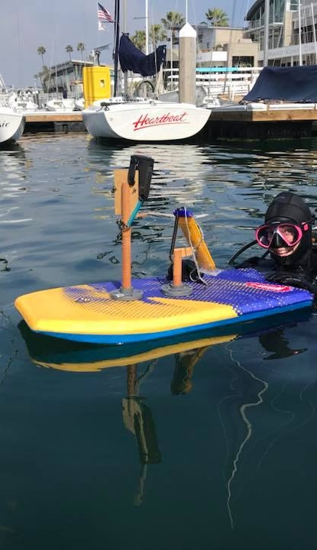
Figure 1. Surface personnel following bubble trails of underwater personnel with GPS tracking unit mounted to a floating board to record the perimeter of the eelgrass bed.
Any notes from divers and surface support regarding deviation from mapped course should be noted and accounted for when processing the map in ArcMaps (ESRI™) or the equivalent. Polygon layers from the GPS unit should be uploaded to a computer with ArcMaps where polygons can be edited. A satellite image overlay should be added as a base map in order to assist divers in referencing landmarks within the bed and for planning transect locations. Within the GIS, Bed Perimeter to the nearest 0.5m, and Bed Area to nearest 0.25m² should be calculated. Area:Perimeter ratio can be subsequently calculated from those measures.
If at any point during the sampling event invasive species are observed at the site (e.g., Caulerpa spp.) appropriate California Fish and Wildlife (https://wildlife.ca.gov/Conservation/Invasives/Species) and NOAA offices (https://www.fisheries.noaa.gov/west-coast/habitat-conservation/caulerpa-species-west-coast) should be informed. Irrespective of observable invasive species presence or absence, care should be taken to prevent biological contamination from site to site and waterbody to waterbody by cleaning and decontaminating all gear between sampling events (e.g., https://invasivemusselcollaborative.net/wp-content/uploads/2018/11/NOAA-Decon-Watercraft.pdf).

Potential modifications to mapping:
In situations where the Sample Bed is a subsample of a larger eelgrass meadow, the normal measurement of the perimeter around that subsample should occur. In addition, a rough mapping of the larger meadow would be encouraged if practical. This can be done in the field using the GPS from the surface support craft or from recent remote sensing imagery or other recent mapping efforts.
If the equipment is available, Sampel Bed perimeter can be measured with sidescan sonar or drone imagery. If these remotely sensed methods are employed, detailed depth measurements around the perimeter of the bed must still be recorded. If either of these methods are to be employed, the field crews should notify the committee co-chairs prior to sampling.

Mapping QA/QC:
At the start of every field day, the GPS unit should be calibrated following the manufacturer’s instructions. Additionally, GPS memory stores should be checked to ensure sufficient memory is available for the beds to be measured on the day.
The perimeter at a minimum of one of every ten beds sampled within a discrete project should be randomly selected apriori to be measured two times. This information will be provided to field crews by the project coordinator. As an example, if four different beds are part of a project, we recommend that one of those beds are randomly selected to be measured twice. Similarly, if there are thirty beds sampled in a given project, we would recommend that three beds be selected for a second perimeter measurement. The second perimeter measurement should serve as a field replicate (and coded as such in data entry) to help quantify method variability.
Eelgrass Aggregation Classification– Discretion on what is a reasonable aggregation of eelgrass shoots to sample and how it would be classified is left to the field crews in the water. However, our guidelines for classification are as follows:
- Patch – a discrete aggregation of plants that is approximately 3m or less along its longest axis.
- Bed – a discrete aggregation of plants that is greater than 3m and less than 75m along its longest axis.
- Meadow – an expansive aggregation of plants that is greater than 75m along its longest axis and more than 20m along its shortest / shallow-to-deep axis.
- Discrete Aggregation – a grouping of above ground plants separated from other groupings by approximately 3m or more of bare / unvegetated sediment

Step 4 – Sampling Design Planning
Using any spatial data and notes from the site recon in Step 1, approximate transect layout and sampling points should be diagramed to prepare for field sampling. The Inner, Mid, and Outer transects should run the length of the longest dimension of the bed, which conceptually will be parallel to shore in discrete beds, at a relatively constant depth. The transects should be approximately 3m between each other. The Inner Transect should be placed approximately 1m to the inside (towards the middle of the bed) of the shallow edge of the Sample Bed. The Mid Transect should be placed through the middle of the Sample Bed. The Outer Transect should be placed approximately 1m to the inside of the deep edge of the Sample Bed. The Cross Transect should run from the shallowest subtidal portion of the bed through the center of the Mid Transect, unless that is impractical due to abrupt changes in bottom depth. In such cases, the Cross Transect, shallow/deep sampling points should be set up independent of each other.
Inner and Outer transect sample points should be established at three equidistant points from the zero marker (see step 5) to the end of the transect. Mid Transect sample points should be established at five equidistant locations from the zero marker (see step 6) to the end point of the primary transect. The Cross Transect sample points should be collected at the shallow and deep ends of the Cross Transect unless, due to the depth variation, a reasonable transect could not be established as noted above.
Shoreline
~1m
~1m
≥5m
≥5m
Inner
Mid
Outer
Zero Point
Transect
Quadrat Sample
Quadrat + Core Sample
Cross
Ideal Bed
Eelgrass
Figure 2 Conceptual diagram of the normal/idealized sampling scheme within an eelgrass bed. Inner, Mid, Outer, and Cross transect lines are indicated by the black arrows across the middle section of the bed and from the deepest to the shallowest locations within the bed. Quadrat sample locations indicated by grey squares and tissue collection locations indicated by the red circles. Note these are not to scale.
Shoreline
Quadrat Sample
Quadrat + Core Sample
Ideal Patch
Eelgrass
≤ 3m

Figure 3 Conceptual diagram of the small patch sampling scheme within an eelgrass bed. Transects are eschewed in favor of one or two haphazardly placed quadrats (grey squares) where all observational measurements are made and from which tissue s are collected (red circles)

~1m
~1m
≥5m
≥5m
Inner
Mid
Outer
Zero Point
Transect
Quadrat Sample
Quadrat + Core Sample
Cross
Ideal Meadow
Eelgrass
Sample Bed Perimeter
Figure 4 Conceptual diagram of the large meadow, sub-sampling scheme within large contiguous bodies of eelgrass bed. Inner, Mid, Outer, and Cross transect lines are indicated by the black arrows across the middle section of the bed and from the deepest to the shallowest locations within the subsection of the meadow. Quadrat sample locations indicated by grey squares and tissue collection locations indicated by the red circles.
Shoreline
~1m
≥5m
≤2m
Mid
Outer
Zero Point
Transect
Quadrat Sample
Quadrat + Core Sample
Narrow Bed
Eelgrass
Cross
Figure 5 Conceptual diagram of the narrow bed sampling scheme within an eelgrass bed. The Mid, Outer, and Cross transect lines are indicated by the black arrows across the middle section of the bed. The Inner Transect is omitted. Quadrat sample locations indicated by grey squares and tissue collection locations indicated by the red circles.

Eelgrass
Zero Point
Transect
Quadrat Sample
Quadrat + Core Sample
Ideal Fringing Bed
≤3m
Mid
Shoreline
Figure 6 Conceptual diagram of the narrow fringe sampling scheme within an eelgrass bed. The Mid Transect line is indicated by the black arrows across the middle section of the bed. The Inner, Outer, and Cross transects are omitted. Quadrat sample locations indicated by grey squares and tissue collection locations indicated by the red circles.

Potential modifications to sample design:
1. With small, discrete patches of eelgrass smaller than 3m in diameter, simple placement of 1 or 2 sample points in the middle of the patch can be substituted for the transect-based approach (Figure 3).
2. In large meadows, where the Sample Bed is a subsample of the larger whole, the primary transect should be placed along a consistent depth range (as determined by diver depth gauge during survey) that can be established – Ideally at the median depth of the meadow. The secondary transect should be placed to capture any depth gradient in those beds (Figure 4).
3. In relatively narrow beds where the average width is less than 7 or 8m, the Inner Transect should be omitted (Figure 5), but the Cross Transect should still be applied
4. In very narrow fringing beds where the width is less than 3m and there is little difference in depth across the bed, the Inner, Outer, and Cross transects can be omitted (Figure 6).

Step 5 – Logger Deployment
If continuous data loggers for environmental conditions (e.g., light, water temperature, salinity, oxygen, current velocity) are to be deployed as part of study, it is recommended that they are done so at least two weeks prior to sampling (e.g., during site recon). Within the Bight 23 Program, these types of activities are optional and should only be deployed if the sampling agency regularly collects these types of data. As such, pre-existing protocols for each such instance should be followed. However, certain generalities for deployment of loggers in concert with eelgrass monitoring should be followed. Given the relatively shallow depth of eelgrass beds and their proximity to intensive human activity, using small, relatively inconspicuous loggers or larger loggers firmly anchored to the substrate are recommended. Light and temperature loggers (OnSet HOBO™ Pendant UA-002-08) are likely the most common types of loggers that one might deploy and can be paired at the different depths within SAV beds. Sensors can be attached to buoys that are rigged to weights via line of a length that will allow the buoy/sensor to float above or within the SAV canopy (e.g., Figure 5). Other types of loggers like salinity, pH, or dissolved oxygen could be deployed at a single point within the canopy, as there is a presumption of less meaningful small-scale of variability or attenuation of water quality variables.
In most estuaries and embayments, loggers will need to be cleaned frequently to remove settling sediment and biofilms. It is recommended that at sites with high public accessibility, loggers be swapped with new loggers or that data are downloaded during each cleaning to ensure that stolen or lost loggers do not result in significant data losses.
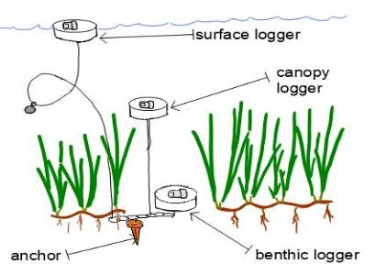
Figure 7 An illustration of an example deployment scheme of paired light and temperature loggers at different points throughout the canopy.

Step 6 – Transect Deployment
Upon entering the water, divers should reacquaint themselves with the location of the eelgrass bed, assess general conditions and water visibility, as well as orient their compasses to the long axis of the Sample Bed. If the long axis is mostly north-to-south – a heading between 315° and 45° or 135° and 225° - then designate the most northern point the zero point of the Inner, Mid or Outer transects. If the long axis is mostly east-to-west – a heading between 314° and 226° or 46° and 134° designate the easternmost point the zero point of the Inner, Mid or Outer transects. For each transect, record the orientation, total length, and number of quadrats to be deployed.
Typically, a transect tape is first laid out across the depth gradient of the bed (conceptually perpendicular to shore and the long axis of the bed) to create the Cross Transect, with the shallow point as the zero point. Record the compass heading of the transect from the zero point. Tent stakes should be used to affix the end of the transect tape on one side of the bed. The Cross Transect should extend up to maximum of ~20m in length.
The Inner-Transect should be deployed along the long axis of the bed approximately 1m from the shallow edge of the bed and across a relatively consistent depth, if possible. The Mid Transect should be deployed across the approximate middle of the bed, parallel to the Inner and Outer transects and following the longest axis of the bed along a relatively consistent depth, if possible. The Outer Transect should be deployed along the long axis of the bed approximately 1m from the deepest edge of the bed and across a relatively consistent depth, if possible. With each transect, record the heading of the transect from the zero point. During deployment of the transect tape, divers should monitor the depth to ensure that no significant changes in depth occur along the transect – this is also checked when recording observational data. The Inner, Mid, and Outer transects should traverse the longest dimension of the bed, as best possible, up to a maximum transect length of ~50m.

Potential modifications to transect deployment
With small, discrete patches of eelgrass smaller than 3m in diameter, transects can be eschewed in favor of haphazard placement of quadrats for sample collection. In large meadows, where the Sample Bed is a subsample of the larger whole, the Mid Transect should be placed along any given isobath that can be established – ideally at the median depth of the meadow. The Inner and Outer transects should be placed relative to the Mid Transect. The Cross Transect should be placed to capture any depth gradient in those beds. In “narrow” fringing beds where the width is less than 2 or 3m there and is little difference in depth across the bed, the Cross Transect can be omitted.
Table 5. Schematic summary of measurements to be made or samples to be collected from each sample collection point within a given eelgrass bed.
Field Measure / Collection of Material | Sample Location
 | in.1 | in.2 | in.3 | mid.1 | mid.2 | mid.3 | mid.4 | mid.5 | out.1 | out.2 | out.3 | cross.1 | cross.2
Percent Cover
Shoot Density
Flowering Shoot Density
Shoot Hieght
Water Depth
Above Ground Material
Below Ground Material
Sediment Composition
Benthic Infauna

Field Measure / Collection of Material | Sample Location
 | in.1 | in.2 | in.3 | mid.1 | mid.2 | mid.3 | mid.4 | mid.5 | out.1 | out.2 | out.3 | cross.1 | cross.2
Percent Cover
Shoot Density
Flowering Shoot Density
Shoot Height
Water Depth
Above Ground Material
Below Ground Material
Sediment Composition
Benthic Infauna

Step 7 – Observational Quadrat Surveys
Two sample points should be established at the shallow (cross.1) and deep (cross.2) ends of the Cross Transect. Five sample points should be established at approximately equidistant points along the Mid Transect, beginning at the zero point of transect (see Step 6) of the transect with sample mid.1 and proceeding to mid.5 (Figure 2). Sample mid.3 should always be the approximate center of the Sample Bed. As an example, if the Mid Transect is 5m long, then a sample would be collected approximately at the 0, 1.25, 2.5, 3.75, and 5m marks. Conversely, in a bed with a 30m transect, samples would be collected approximately at the 0, 7.5, 15, 22.5, and 30m marks. Three sampling points should be established at approximately equidistant points along each of the Inner and Outer transects. Spacing of quadrats should follow the guidelines of the Mid-Transect. Samples should be a minimum of 1m apart from each other. The types of measurements or samples to be collected in each sample location are summarized in Table 5.
1. At all sample locations lay a weighted 0.5x0.5m quadrat down on a predetermined random side (left or right) of the of the transect with the bottom corner of the transect aligned with the determined sample location. The quadrats located at the edges of the bed should be placed as much within the bed as possible.
2. If possible, take a picture of the quadrat from a top-down angle if visibility allows for full view of the transect without losing sight of the sediment surface. Notes should be taken to reflect the intensity of surge or other possible factors that might have interfered with photo representation of the actual quadrat in a way that would affect percent cover estimation – i.e. diver unable to maintain a proper overhead view while taking photos in high surge water.
3. Percent Cover is an approximation of the amount of the surface area delineated by the quadrat that is covered by eelgrass vs. bare sediment/macroalgae/other cover. Visual estimates should be made as a continuous value between 0-100% by the diver from a consistent, typically overhead /plan view viewpoint. Before each dive, it is recommended that divers benchmark their estimates to a visual standard (e.g., www.seagrasswatch.org/manuals/#guides)
4. Percent Macroalgae is an approximation of the amount of surface area delineated by the quadrat that is covered by macroalgae (including eelgrass coverd by macroalgae).
5. Shoot Density is measured by counting the number of shoots within the quadrat. Shoot counts are done by using a string affixed to the quadrat, which is used to fold counted shoots under to keep track of progress through the quadrat. A single shoot is counted by feeling for the stem protruding from the sediment surface. It is not counted as individual leaves, which can branch into multiples at the tip of the stem. If shoot densities are over 100 per 0.25m², a smaller 0.25x0.25m (0.0625m²) quadrat can be used in lieu of the regular quadrat to expedite the process.
6. Flowering Shoots Density should be recorded during measurement of total shoot density. If a bed is blooming at time of sampling, the number of shoots with flowers or seed packets/spathes should be noted during the shoot density measurement.
7. Shoot Height is measured using a small (<2m long) transect tape or metric measuring stick. One diver holds and moves the measuring device to the base of each of five randomly selected shoots within the quadrat. The other diver measures and records the height. Shoots are measured from the base of the sediment to the tip of the tallest leaf on one shoot per replicate. If the selected leaf contains is flowering, make a note of it. Do not measure multiple leaves on one shoot. If there are less than 5 shoots within the quadrat, there will be less than 5 replicates.
8. Water depth at the sediment surface should be recorded from dive computers for each sample location.
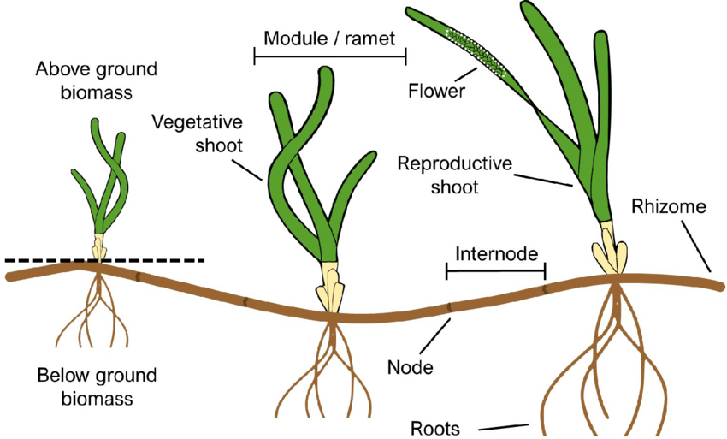
Figure 8. Diagram displaying where to measure shoot height. (Howarth, L.M., Lewis-McCrea. L., LaBelle, J., and Reid, G.K., (2021) Managing Aquaculture and Eelgrass Interactions in Nova Scotia. Centre for Marine Applied Research (CMAR), Dartmouth, Nova Scotia, Canada.)

Potential modification to observational quadrats:
Patches - With small, discrete patches of eelgrass smaller than 3m in diameter, place 1 or 2 quadrats within the eelgrass. If the patch is large enough to place 2 quadrats while maintaining approximately 1m distance between them, do so labelling them samples mid.1 and mid.3. Otherwise use 1 quadrat in the center, as sample mid.3. Collect all measures as noted above.

Observational survey QA/QC
Measures of percent cover, shoot density, flowering shoot density, and shoot height should be measured independently by both divers to capture measurement variance. Data should be designated as Diver A or Diver B during data entry.
At a minimum, 10% of the total number of beds sampled during a project should be resampled as a field replicate with the same or different pairs of divers on the same day of sampling. As an illustration, if 7 beds are sampled during the course of a project, we recommend that 1 bed should apriori be randomly selected to be resampled. Similarly, if 25 beds are sampled during the course of a project, 3 should be randomly selected for resampling.
If the randomly selected bed is wide enough, the Inner, Mid, Outer and Cross transects can be re-laid and all of observational measures, including Diver A and Diver B measures, can subsequently be collected to serve as a field replicate (and coded as such in data entry) to help quantify method variability. If the bed is too narrow to place another set of transects through a different part of the bed, the same transect can be used for the field replicate. However, in this instance the quadrats should be placed on the opposite side of the transect as they were for the original measure. As an illustration, if the quadrat at sample mid.1 was placed to the right of the transect line during the initial sampling, then the replicate would be placed to the left.

Step 8 – Above Ground & Below Ground Eelgrass Collection
At sample locations mid.1, mid.3, mid.5, cross.1, and cross.2, eelgrass tissue should be collected for above ground (shoots and leaves) and below ground (roots and rhizomes) material and placed in pre-labeled, sealable plastic bags. Ideally sample bags will have both an interior and exterior label. The goal is to collect all material from a known area (e.g., g cm⁻²)
- Place a 10-cm (i.d.) ring on the sediment surface within the quadrat to demarcate the area to be sampled. All plants (above and below ground) within the ring are to be collected. The sample location should contain at least one shoot and there should be little to no obvious obstacles – e.g., large rocks or shelled invertebrates – that could prevent subsequent collection of below ground material.
- To free the below ground eelgrass material (i.e., roots and rhizomes) within the footprint of the ring, a variety of approaches can be used to remove the material. Care should be taken to minimize the inclusion of rhizomes that run outside the footprint of the ring.
  - A metal trowel can be used to cut the rhizomes within the ring and excavate the eelgrass and associated sediment
  - A pair of scissors or other cutting device can be used to clip the rhizomes along the perimeter of the ring and rhizomes pulled out
- Once the below ground eelgrass material has been freed from the surrounding be, one diver holds the plastic bag, while the other diver gently pulls the plants out from the sediment. The plants can be gently swooshed through the water to remove loose sediment, though this may reduce visibility. Care should be taken to make sure all material from within the footprint of the 10-cm ring is collected.
- Plants are gently placed into labeled sample bags. With long shoots, gently rolling the SAV tissue into a coil will help to make the tissue fit. Before sealing, most of the water within the bag should be pushed out carefully without pushing out SAV tissue. This will help reduce the sample weight when divers exit the water, as a potential total weight of all sample bags filled with water can exceed 40 lbs.
- Divers can elect to place the plastic sample bags in mesh dive bag and retain all of the samples during sampling. Alternatively, samples can be given to surface support crew, or they can be marked with a pop-up surface buoy and collected after sampling.
- Once samples are removed from the water, the seals should be checked on the bags, the internal and external labels should be confirmed that they are intact, and then the bags should be placed into a cooler.

Potential modifications to above ground collection
At small, discrete patches less than 3m in diameter, eelgrass material should be collected at all (i.e., 1 or 2, depending on size) of the quadrats placed in the patch. In narrow beds less than 1m wide, the cross.1 and cross.2 samples should be omitted, as noted above.

Above ground QA/QC
At a minimum, 10% of the total number of beds sampled during a project should be resampled as a field replicate. As an illustration, if 7 beds are sampled during the course of a project, we recommend that 1 bed should apriori be randomly selected to be resampled. Similarly, if 25 beds are sampled during the course of a project, 3 should be randomly selected for resampling.
If the randomly selected bed is wide enough, the Inner, Mid, Outer, and Cross transects can be re-laid and all the above ground samples can subsequently be collected to serve as a field replicate (and coded as such in data entry) to help quantify method variability. If the bed is too narrow to place another set of transects through a different part of the bed, the same transect can be used for the field replicate. However, in this instance the material should be collected from the opposite side of the transect as they were for the original measure. As an illustration, if the quadrat and subsequent tissue collection at sample mid.1 were placed to the right of the transect line during the initial sampling, then the replicate would be placed to the left.

Step 9 – Sediment Collections
A small core for sediment grainsize, TOC, and TN content should be collected within quadrat mid.3.
- A core ~3cm i.d., should be inserted approximately 5cm into another, preferably unvegetated portion of the quadrat for Sediment Analysis. A 50-cc syringe with the bottom cut off works well for this. The target mass is at least 100g of sediment. This is not an area-based measurement (i.e., results are percentages by mass), so use of the corer is only to facilitate clean collection of sediment and therefore the exact size of the core can vary.
  - Note - if a hydrometer is to be used for sediment analysis more than 100g of sediment is needed. As such, multiple small cores of sediment should be collected. The project coordinator should be consulted prior to the beginning of the project.
- The Sediment Analysis core should be pulled from the sediment and the contents extruded into a small sealable plastic bag with interior and exterior labels.
- Once the samples are placed in their respective plastic bags, they are stored in a mesh dive bag for temporary transport throughout the rest of sampling or transferred to surface support crew and placed in a cooler.

Sediment QA/QC
At a minimum, 10% of the total number of beds sampled during a project should be resampled as a field replicate. As an illustration, if 7 beds are sampled during the course of a project, we recommend that 1 bed should apriori be randomly selected to be resampled. Similarly, if 25 beds are sampled during the course of a project, 3 should be randomly selected for resampling. The same sample locations used for the above ground field resampling should be used for the below ground resampling.

Step 10 –Infauna Collection (Optional)
A 10cm(i.d.) X 15cm long core should be used to collect a sediment sample for infauna. The sample should be collected near the center of the bed, though it does not have to be within the quadrat associated with sample mid.3.
- Identify a location near sample quadrat mid.3 and insert the core a minimum of 10cm into the sediment with a twisting motion to cut through the rhizomes. Remove as much of the above ground vegetation as possible without pulling up surface sediment.
- The core should be wiggled in a circular manner to dislodge surrounding sediment and allow enough space for the diver to reach a hand down to the bottom of the core and cover the bottom and prevent the contents from dislodging.
- Removal of the core should be done slowly while the bottom of the core is covered, then divers may move slightly adjacent to the core location before pushing the contents of the core into a plastic bag with interior and exterior labels held by the other diver. Moving slightly away for the transect might allow for enhanced visibility, as the sediment coring process can disturb sediment and reduce visibility in the immediate area.
- Upon completion of all of the diving tasks, there are a few options for the field crews to choose in processing the material in the bag prior to returning to the laboratory.
  - Sieving material “in the field”. The goals of this option are to remove as much sediment and fine organic matter as possible prior to fixing of the sample, as well as to minimize the amount of extraneous sediment and detritus brough back to the lab.

Contents of the bag should be placed into a sufficiently sized 500µm screen . Material can be then sieved in the ambient water. Make sure to get all of the material from inside the plastic bag. When sieving, being quick will help to prevent animals from wrapping themselves within the screen and being gentle will minimize damage to the fauna from the sloshing of sand and shells. Sieved material should then be placed in a screw-top container, with care taken to make sure animals and detritus are not retained on the screen. Ideally, the sample material should occupy a third to half of the container’s volume in total Squeeze bottles and forceps can be helpful to ensure collection of all animals. Jars should be placed on ice until they can be chemically preserved in the laboratory (Step 12-3). Alternatively sieved material can be placed back into the plastic bag to be transferred to a jar in the laboratory.
  - Sieving material “in the lab”. The goals of this option are to reduce the amount of time in the field while still removing as much sediment and fine organic matter as possible prior to fixing of the sample. Sample bags must be kept on ice to minimize decomposition of the fauna in the core until they can be fixed in the laboratory.
  - Whole core preservation. The goals of this approach are to reduce the amount of time in field and in the lab upon return from the field, as well as minimize “escape” of the animals during sample processing. Sample bags must be kept on ice to minimize decomposition of the fauna in the core until they can be fixed in the laboratory.

Potential modifications to infauna collection
At small, discrete patches less than 3m in diameter, the core for infauna can be taken in the approximate center of the patch.

Infauna collection QA/QC
At a minimum, 10% of the total number of beds sampled during a project should be resampled as a field replicate. As an illustration, if 7 beds are sampled during the course of a project, we recommend that 1 bed should apriori be randomly selected to be resampled. Similarly, if 25 beds are sampled during the course of a project, 3 should be randomly selected for resampling. The resample core for infauna should be collected near the center of the bed, but away from sediments disturbed during other sampling activities. The resample core(s) should be used quantify method variability.

Step 11 – Field Debriefing
One diver moves samples to a cooler with ice immediately after divers exit the water and remove gear, while the other diver records sample conditions and checks data recordings for clarity:
1. Divers exit the water and remove SCUBA gear while ensuring that sample bags are carefully placed aside and not punctured. Inspect for leaking and have both field personnel work on fixing leaks by double bagging samples quickly.
2. Samples are placed over ice inside a large cooler. A cooler with at least 15-gallon capacity is recommended to fit all sample bags filled fully.
3. Field conditions – water temperature, visibility, air temperature, sea surface state, weather conditions – should be recorded.
4. All underwater personnel should review and discuss the data recorded on the dive slates to ensure that underwater handwriting is legible. Data can be transferred to waterproof data sheets, if time and conditions allow
5. A photo should be taken of the dive slate(s) with all data on it visible, including date and site information. The photo should be emailed or uploaded to a cloud storage drive for secure storage of the data and ease of access for data entry personnel.
6. The Field Collection Inventory Sheet should be filled out.

Lab Plan SOPs

Step 12 – Sample Sorting and Preparation
To prevent degradation and breakdown of the eelgrass material, samples should be taken back to the laboratory as soon as possible to be sorted, cleaned and stored.

Following fieldwork
- Sediment for grainsize, TOC, and TN analysis can be refrigerated for up to 48 hours before processing or frozen (-20°C) for long-term storage.
- The eelgrass material should be split into above ground and below ground tissue portions. Above ground tissue samples should be cut at the point where the sheath meets the rhizome (See Figure 8). Above ground and below ground material should be placed into separate containers and placed on ice/in the refrigerator until they are processed (or processed directly, if time/personnel allow for it). The above ground material should not contain any belowground tissue (i.e., roots and rhizomes).
- If samples for infauna are collected, the material (fauna, detritus, and sediment) needs to be fixed or preserved in some fashion upon return to the lab. Do not allow material to remain on ice un-fixed overnight.
  - If infauna samples are “sieved in the field” (Step10-4a) but not yet in a screw-top container, the material should be transferred to a container. Rinse the sample bag into a 500µm screen and transfer any retained material into the sample container. Squeeze-bottles and forceps can be helpful to ensure collection of all animals. At a maximum, the sample material should occupy a third to half of the container’s volume in total.
  - If infauna samples are to be “sieved in the lab” (Step 10-4b), contents of the sample bag should be placed into a sufficiently sized 500µm screen. If the process gets “clogged”, sieve the material in aliquots. Ideally material would be sieved using water of a similar salinity but tap water can be used if need be. Make sure to get all of the material from inside the sample bag. When sieving, being quick will help to prevent animals from wrapping themselves within the screen and being gentle will minimize damage to the fauna from the sloshing of sand and shells. All material retained on the screen should then be placed in a screw-top container, with care taken to make sure animals and detritus are not stuck on the screen. Squeeze-bottles and forceps can be helpful to ensure collection of all animals. At a maximum, the sample material should occupy a third to half of the container’s volume in total.
  - If infauna samples are to be “whole core preserved” (Step 10-4c), contents of the sample bag should be placed into sufficiently large screw-top containers. At a maximum, the sample material should occupy a quarter to a third of the container’s volume in total. The amount of water included in the container should be minimized, so any water in the bag or container should be decanted out over a 500µm screen. The sample bag should be thoroughly rinsed into the 500µm screen. All retained material should be put into the container with the rest of the sample. Squeeze-bottles and forceps can be helpful to ensure collection of all material from the screen.
- Infauna samples intended for traditional morphological identification should be fixed with a buffered formalin solution. Formalin should be buffered by diluting it to the targeted concentration with full strength seawater and / or adding a dissolved borax (sodium borate) solution to the sample together with the formalin. Samples intended for genetic identification should only be preserved with a 95% ethanol solution mixed volumetrically at 95 parts 95% non-denatured ethanol and 5 parts glycerin.
  - If samples were sieved in the field or at the lab (Steps 10-4a or 10-4b above) 10% buffered formalin should be added to the container to create a minimum 1:2 or 1:3 sample to formalin solution ratio. If there is a large amount of organic matter (e.g., eelgrass rhizomes or old leaves) in the sieved material consider changing the formalin ratio to 1:4 or use a 20% formalin solution.
  - If samples were not sieved (Step 10-4c above) 20% buffered formalin should be added to the container at a minimum 1:3 sample to formalin solution. If there is a large amount of organic matter (e.g., eelgrass rhizomes or old leaves) visible in the sample, consider changing the formalin ratio to 1:4 or use a 30% formalin solution.
  - Once the formalin has been added to the container seal it and gently agitate it to help formalin penetrate the material. Do not violently shake it. Stirring the contents of the container w/ long spoon is a potential option if the seal of the container is not trustworthy.
- All sample labels should be double checked for proper labeling and confirmed with the dive team before departing for the day.

Before sample processing
- Labeled weighboats for each sample location should be prepared for below ground tissue, above ground tissue, and epiphytes. Note – this can be done weeks ahead of time, as long as combusted weighboats are kept in a non-humid environment (e.g., drying oven or dessicator)
  - Weighboats for below and above ground biomass can be sheets of heavy-duty aluminum foil or large commercial aluminum weighboats. Weighboats for epiphyte biomass can be smaller. All weighboats should be combusted at 550 °C for 6hrs. Label each boat with a pencil prior to combustion, indenting the aluminum such that the label can be read after the pigment is combusted.
  - After cooling, the sheets or boats should be weighed on an electric balance to the nearest 1.0 mg and the value recorded as the pan weight.
  - Note that samples of the above ground and below ground tissue may be bigger than typical commercial weigh boats. In these instances, homemade weighboats can be created with heavy duty aluminum foil crimped to form a container.
For Steps 13 -18.1, we recommend working with one sample bag at a time. Labeling and organizing samples for Step 18 – Aboveground Biomass.

Step 13 – Shoot Count
Shoots from the sorted above ground tissue samples should be removed from their sample bag and gently laid out onto a flat surface. The total number of intact shoots in an above ground tissue sample should be recorded (Figure 9). Each shoot within a sample should then be assigned a Shoot ID using a Sample Number – Shoot Number format to keep track of it across all shoot-based measurements – e.g., mid.1-Shoot 1, mid.1-Shoot 2, etc. All loose leaves in the sample should be placed to the side until it is time to measure above ground biomass.

Step 14 – Leaves per Shoot
The number of individual leaves should be counted for each shoot (Figure 9). This value should be recorded as the measure of Leaves per Shoot. Measurements should be tracked using the shoot ID scheme established in Step 14.

Step 15 – Epiphyte Biomass
Note – Measurement of epiphytic material is the most time sensitive and delicate measurement. The material is susceptible to loss, as well as, physical or biological degradation. Epiphytic material (algal, animal, or abiotic) should be carefully removed from all the leaves in each sample. Shoots and leaves should remain intact to be measured in Steps 13-16 Epiphyte biomass should be measured as wet mass, dry mass, and ash free dry mass to the nearest 1.0 mg using an electronic balance. In between mass measurements, epiphyte samples should be kept in a lidded container to prevent contamination. If any measurement value is less than the detection limit of the balance, record the smaller of 0.1mg and the detection limit of the balance as the mass value.
- Gently shake the aboveground biomass content in the sample bag and pour the sample bag contents into a 63µm sieve. Then rinse the bag with water and pour the remaining water from the bag into the sieve
- Using a squirt bottle, squirt water onto the sieve to collect the solid material into one corner of the sieve. Remove all the material off of the sieve into a large petri dish.
  - Thoroughly wash the sieve in between samples.
- Slowly and firmly run the edge of the glass slide on both sides of every leaf in the shoot from base of each leaf to the tip. Make sure to be especially gentle around areas with perforations or tissue degradation on the leaves.
- Record any clear instances of wasting disease. – see http://www.seagrassli.org/ecology/wasting_disease.html
- Contents of the scraping should be placed in the same petri dish as steps 1 and 2. The dish should be examined for general contents and sorted to remove any pieces of eelgrass.
- Epiphytic matter should then be placed in the appropriate combusted and labeled weighboat for that sample with a minimum amount of excess water. Measure the contents of the weighboat. Subtract the pan weight from this value to obtain the Epiphyte Wet Mass.
- Once wet mass has been measured, place the material+weighboat into a drying oven at 60℃ for a minimum of 48hrs. After the minimum 48hrs, remove samples from the drying oven and allow to cool in a desiccator. Measure the contents of each weighboat. Subtract the pan weight from this value to obtain the Epiphyte Dry Mass.
- Once dry mass has been measured, place the material+weighboat into a muffle furnace at 550℃ for 4hrs. Allow samples to cool in the oven and then move to a desiccator. Measure the contents of each weighboat. Subtract the pan weight from this value to obtain the ash mass. Subtract the ash mass from the dry mass to obtain the Epiphyte Ash Free Dry Mass.

Epiphyte QA/QC
Calibrate the balance following manufacturer’s instructions prior to each day of use. With every 10% of samples, a second person should inspect the leaves of a sample to make sure that all epiphytic material was removed and that leaf tissue was left relatively intact.

Step 16 – Shoot Height and Width
The length of each intact shoot from its base to the tip of its longest intact leaf should be measured to the nearest 0.1mm (Figure 9). The width of the shoot should be measured in the middle of the same leaf. When recording the measurements, the Shoot ID scheme established in Step 13 should be used to track the data.
Note- Shoot height and average width may also be obtained when measuring leaf area, depending on the manufacturer and model of the equipment (e.g., LiCor Leaf Meter). If preferred, these measurements can be obtained when measuring Step 17 and noted in the comment field.
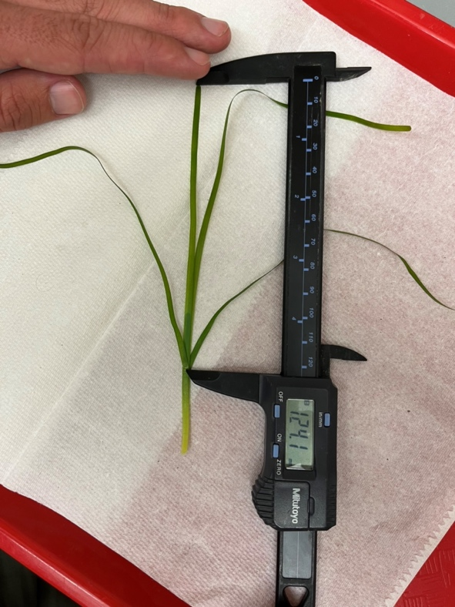
Leaf 1
Leaf 2
Leaf 3
Leaf 4
Figure 9. An example of an eelgrass shoot with 4 intact leaves and a shoot length of 124.1 mm.
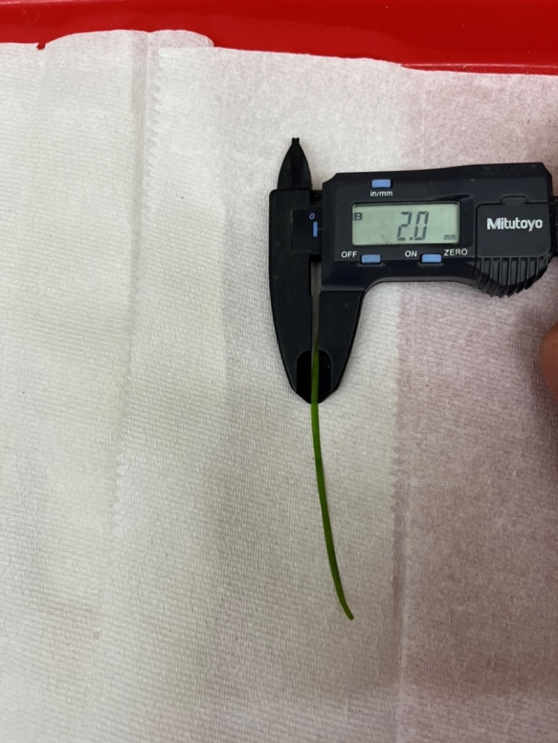
Figure 10. An example of an eelgrass leaf and a width of 2.0mm.

Step 17 – Leaf Area
After Steps 13-16, the longest leaf from each shoot in a sample should be removed and used to measure leaf area to the nearest 1.0mm². If the leaves have dried, then they should be rewetted. Leaf area can be calculated using a leaf area meter or a calibrated bench-top scanner and area estimating software (e.g., https://imagej.nih.gov/ij/download.html). Measurements should be tracked using a Shoot-ID scheme established in Step 13.
- Cut the leaf at the basal end. Cuts should be made at the top of the blade sheath, which is located above the stem and below the base of each leaf. Set the remaining leaves aside for subsequent measure of above ground biomass.
- Ideally, damaged or broken leaves should not be measured. If the longest leaf in the shoot appears to have been damaged during collection, select the next longest leaf within the shoot.
- Separated leaves can be placed in a small amount of seawater in a large petri dish to keep the leaves from wilting.
- Wetted leaves should be blotted dry before measuring area.
  - Area can be measured with a leaf area meter (LI-COR™ LI-3100C Area Meter). Make sure each blade is laid flat longwise when running through the meter sensor. Three runs are done for each leaf and the mean is reported as Leaf Area to the nearest 1.0mm².
  - Area can also be measured by scanning the leaves on a benchtop scanner and a 10mmX10mm scale block. Leaf Area can then be calculated from the calibrated images using a standard image analysis software package.
- After measuring the leaf area, place the measured leaf with the rest of the shoot material for subsequent measuring of above ground biomass.
Optionally, after completing steps 13-17, above ground tissue can be frozen (-20°) if biomass measurements are not going to be started within 24hrs of collection.

Step 18 – Above Ground Biomass
Biomass of the above ground tissue should be measured as wet mass, dry mass, and ash free dry mass to the nearest 1.0 mg using an electronic balance. In between mass measurements, samples should be kept in a lidded container to prevent contamination. If any measurement value is less than the detection limit of the balance, record the smaller of 0.1mg and the detection limit of the balance as the mass value. If measuring frozen samples, allow them to completely thaw in covered conditions.
- Above ground tissue with the epiphytes removed should be patted dry with paper towels (if leaves have dried, then leaves should be rewetted), placed in the appropriate combusted and labeled weighboat for that sample. Measure the contents of the weighboat. Subtract the pan weight from this value to obtain the Above Ground Wet Mass.
- Once wet mass has been measured, place the tissue+weighboat into a drying oven at 60℃ for a minimum of 48hrs. After the minimum 48hrs, remove samples from the drying oven and allow to cool in a desiccator. Measure the contents of each weighboat. Subtract the pan weight from this value to obtain the Above Ground Dry Mass.
  - If eelgrass TOC and TN content are to be measured, remove 2.5-3mg of dried tissue prior to combusting the sample for calculation of ash free dry mass. Record the amount reserved for TOC/TN analysis.
- Once dry mass has been measured, place the tissue+weighboat into a muffle furnace at 550℃ for 6hrs. Allow samples to cool in the oven and then move to a desiccator. Measure the contents of each weighboat. Subtract the pan weight from this value to obtain the ash mass. Subtract the ash mass from the dry mass to obtain the Above Ground Ash Free Dry Mass.
- Once calculation of ash free dry mass has been made for the sample, calculate the ratio of dry mass to ash mass. Divide the mass of tissue reserved for TOC/TN analysis by the dry:ash ratio and add that value to the ash free dry mass value calculated in Step 19.3 to produce a Corrected Above Ground Ash Free Dry Mass value corrected for the removal of tissue between drying and ashing. The use of the “corrected ash free dry mass” value is important to accurately scale the sample measure up to areal or density-based estimates or comparison with samples for which TOC/TN content was not assessed.

Step 19 – Below Ground Biomass
Biomass of the below ground tissue should be measured as wet mass, dry mass, and ash free dry mass to the nearest 1.0 mg using an electronic balance. In between mass measurements, samples should be kept in a lidded container to prevent contamination. If any measurement value is less than the detection limit of the balance, record the smaller of 0.1mg and the detection limit of the balance as the mass value. If measuring frozen samples, allow them to completely thaw in covered conditions.
- Below ground tissue should be removed from any accompanying sediment by carefully sifting through sediment with hands and pulling out the rhizomes and attached roots. Gently rinse off any attached sediment from the rhizomes over a 1-mm screen with tap water. Place the tissue onto the appropriate weighboat. Rinse all remaining sediment in the sample bag through the 1-mm sieve and pull out any visible root or rhizome tissue. Add them to the labeled weighboat.
  - Only live rhizome/root structures should be measured. Many dead or decaying rhizomes may be present in the form of soft, dark material that can be removed from the sample prior to measuring the mass. Live rhizomes will have a slightly orangish-brown appearance when fresh and have a degree of rigidity. However, if there is doubt as to the live/dead nature of a rhizome, keep it in the sample; do not remove it.
  - Pat all tissue dry with a paper towel
  - Below ground samples can be measured fresh, if measurements are made within 24hrs of collection – being kept in a refrigerator in the interim – or they can be frozen (-20°C) after cleaning off the associated sediment. If freezing, sort out any dead or decaying rhizomes before placing the material in a sealed plastic bag for freezing instead of the weighboat.
- Cleaned below ground tissue should be patted dry with paper towels, placed in the appropriate combusted and labeled weighboat for that sample. Measure the contents of the weighboat. Subtract the pan weight from this value to obtain the Below Ground Wet Mass.
- Once wet mass has been measured, place the tissue+weighboat into a drying oven at 60℃ for a minimum of 48hrs. After the minimum 48hrs, remove samples from the drying oven and allow to cool in a desiccator. Measure the contents of each weighboat. Subtract the pan weight from this value to obtain the Below Ground Dry Mass.
  - If eelgrass TOC and TN content are to be measured, remove 2.5-3mg of dried tissue prior to combusting the sample for calculation of ash free dry mass. Record the amount reserved for TOC/TN analysis.
- Once dry mass has been measured, place the tissue+weighboat into a muffle furnace at 550℃ for 6hrs. Allow samples to cool in the oven and then move to a desiccator. Measure the contents of each weighboat. Subtract the pan weight from this value to obtain the ash mass. Subtract the ash mass from the dry mass to obtain the Below Ground Ash Free Dry Mass.
- Once the calculation of ash free dry mass has been made for the sample, calculate the ratio of ash free dry mass to dry mass. Multiply the mass of tissue reserved for TOC/TN analysis by the ash:dry ratio and add that value to the ash free dry mass value calculated in Step 13.3 to produce a Corrected Below Ground Ash Free Dry Mass value corrected for the removal of tissue between drying and ashing. The use of the “corrected ash free dry mass” value is important to accurately scale the sample measure up to areal or density-based estimates or comparison with samples for which TOC/TN content was not assessed.

Below ground biomass QA/QC
Calibrate the balance following manufacturer’s instructions prior to each day of use.

Step 20 – Sediment Grainsize
Preferably, grainsize should be measured using the laser refractometer method (e.g., Beuselinck et al. 1998), which can be done either “in house” or via a contracting laboratory. If a laser refractometer is not available, the pipette (e.g., Plumb 1981) or hydrometer (Bouyoucos 1962) method is acceptable. When using a contracting laboratory, make sure to discuss the nature (frozen, wet, dry, etc) and volume of sediment needed by the lab for grainsize analysis. When recording the data, the method must also be recorded. Data should be reported as %phi, if using the preferred refractometer method. Alternatively, % Sand, Silt, and Clay can be reported, if measured using the by the pipette or hydrometer methods.
If sediment TOC and TN are to be measured, a portion of sediment should set aside prior to grainsize analysis. This sediment should be dried in a drying oven at 60°C for at least 48hrs. The goal is to produce between 2.5 and 3g of dried sediment for TOC/TN analysis. Depending on the bulk density of the fresh sediment, the amount needed to set aside will vary.

Sediment grainsize QA/QC
A minimum of one grainsize sample per analytical batch should be selected for reanalysis. These lab replicates are used to quantify method variability. They should be indicated as lab replicates when entering the data. All equipment (e.g., refractometer or electronic balance) should be calibrated according to manufacturers instructions with each batch of samples analyzed.
- From grainsize data, %Sand, %Silt, and %Clay should be calculated from the phi sizes – if using the laser method – or measured from the appropriate dried aliquots – if using the pipette method.
- For each of the lab replicate samples, the relative percent differences (RPD) for each of sand, silt, and clay values between the two replicates should calculated by:
RPD={[Absolute(%Sand_{Rep1} – %Sand_{Rep2})]/[(%Sand_{Rep1} + %Sand_{Rep2})/2]}*100

- If the RPD is greater than 25% for any of the three measures, then those measures within the entire batch should be flagged as highly variable

Step 21 – Total Organic Carbon and Total Nitrogen
Total organic carbon (TOC) and total nitrogen (TN) content of the bulk sediment and eelgrass tissue should be measured via combustion with an elemental analyzer. This can be done either “in house” or via a contracting laboratory. Typically ~2.5g of acidified and dried material are needed for analysis, though the contract lab’s specifications and manufacturer’s protocols may differ. Make sure to adjust the sample portioning of dried eelgrass (Steps 18 and 19) and sediment (Step 20) based upon analytical requirements specified by the contract lab. Sediment TOC and TN, Above Ground TOC and TN, and Below Ground TOC and TN should be reported in the nearest 0.01mg g⁻¹. Sample type should be indicated as sample and matrix as sediment or SAV tissue, as appropriate.

TOC and TN QA/QC
A minimum of one TOC/TN sample for sediment per analytical batch, as well as for above ground and below ground eelgrass tissue, should be selected for reanalysis. These lab replicates are used to quantify method variability. They should be indicated as lab replicates when entering the data. The elemental analyzer should be calibrated following the manufacturer’s recommendations. Once per 20 samples or once per laboratory batch, whichever is more frequent, standard reference material for TOC and TN should be analyzed to provide a check of data accuracy. Sample type should be indicated as standard.
- The relative percent difference (RPD) for each of TOC and TN between laboratory replicates should be calculated by
RPD={[Absolute(TOC_{Rep1} – TOC_{Rep2})]/[(TOC_{Rep1} + TOC_{Rep2})/2]}*100

- If the RPD is greater than 25% for either of the two measures, then those measures within the entire batch should be flagged as highly variable
- Percent recovery for each of TOC and TN for each laboratory standard should be calculated by:
% Recovery=(TOC_{measured}/TOC_{expected})*100
- If percent recovery is <80 or >120, the analysis should be stopped and an additional reference material sample should be measured.
- If percent recovery is still outside of the target, then the machine should be recalibrated until suitable performance can be achieved. The 20 samples associated with the reference material should be flagged as inaccurate.

Step 22 –Infauna Analysis (Optional)
Samples should remain exposed to formalin for 5 -7 days. Longer periods are okay, but organisms with calcium carbonate structures (i.e., molluscs, echinoderms) will begin to dissolve. This will hamper their accurate identification. Even with the buffer, the formalin will eventually begin to dissolve the calcium carbonate structures. After sufficient exposure to formalin, the samples should be rinsed with tap water in a 500µm sieve. After rinsing, drain as much water as is possible. All material should be returned to its original container and covered with a 70% non-denatured ethanol solution. Ensure that no material remains on the sieve from rinsing. Enough ethanol should be added to the container to cover the material by 5 – 6cm (i.e., 3 fingers). Samples should be stored in a cool (~room temperature), dark place
Note that whole core preserved samples (step 10-4c) will produce a potentially large amount of sediment and small organic matter particles when being washed. This can present a challenge to plumbing/sewer systems. Collection of this material into a tub or bucket is highly recommended.
After benthic infauna samples have been transferred to ethanol for 5 days they can be processed. The target is that all macrobenthic organisms alive at the time of sample collection should be sorted from the associated detritus, identified, counted, measured for biomass. Taxonomic identification of benthic infauna requires a reasonable amount of specialized skill and equipment. As such, samples can be sorted and identified “in house” or by an external laboratory, but will mostly likely have to be sent to an external taxonomy lab. Conversely, most taxonomic labs are not equipped to calculate infauna biomass, so that would have to be measured in house.
Infaunal analysis is multi-step process that begins sorting of organisms from the detritus, identification and enumeration of the individuals, and measurement of biomass. Sorting, identification, and enumeration should follow details in the Bight 23 Macrobenthic Infauna Lab Manual http://ftp.sccwrp.org/pub/download/BIGHT23/Bight23SedQualityBenthicLabManual.pdf . Note, the Bight Macrobenthic Infauna Lab Manual does not cover any steps related to measurement of biomass. These key additions are covered below. The processing of the samples will entail:
- Infauna should be sorted from the detritus, typically under stereo microscope. A sorting sheet like the one in the Bight 23 Macrobenthic Lab Manual should be used to keep track of sorting progress and QA/AC. The organisms removed from the sample are sorted into taxonomic lots for subsequent taxonomic analysis. Typically, organisms are sorted into annelids, arthropods, echinoderms, molluscs, and miscellaneous phyla (e.g., cnidarians, nemerteans). However, each laboratory will determine the taxonomic level of sorting adequate to their needs for subsequent sample analysis by their taxonomists. Meiofauna, wholly planktonic organisms, and the planktonic juveniles of benthic fauna should not be retained. All fragments such as decapod chelae and legs, should be placed in their respective taxa lots.
- All of the sorted organisms contained within each sample should be identified to the lowest possible taxonomic category and counted. The target of the analysis is to provide species level identifications whenever possible. Nomenclature and orthography follows that used in the most recent SCAMIT species list (www.scamit.org). Identified organisms should be vialed separately from each other with an internal label indicating the taxonomic ID, station name, and taxonomists initials. Fragments of organisms should be vialed with the appropriate identified and counted taxa, as best the taxonomist can determine. Fragments that cannot be associated with any identified organisms should be vialed and labelled as misc. tissue.
- Once all samples have been identified and passed sorting and identification QA/QC, biomass can be measured. Taxon-specific biomass should be measured as wet mass, dry mass, and ash free dry mass to the nearest 1.0 mg using an electronic balance. In between mass measurements, samples should be kept in a lidded container to prevent contamination. If any measurement value is less than the detection limit of the balance, record the smaller of 0.1mg and the detection limit of the balance as the mass value.
  - All individuals (and associated fragments) of a given taxon should be patted dry with a ChemWipe, placed a pre-combusted, weighed, and labeled weighboat. Measure the contents of the weighboat. Subtract the pan weight from this value to obtain the Wet Mass for that taxon.
  - Once wet mass has been measured, place the tissue+weighboat into a drying oven at 60℃ for a minimum of 48hrs. After the minimum 48hrs, remove samples from the drying oven and allow to cool in a desiccator. Measure the contents of each weighboat. Subtract the pan weight from this value to obtain the Dry Mass for that taxon.
  - Once dry mass has been measured, place the tissue+weighboat into a muffle furnace at 550℃ for 6hrs. Allow samples to cool in the oven and then move to a desiccator. Measure the contents of each weighboat. Subtract the pan weight from this value to obtain the ash mass. Subtract the ash mass from the dry mass to obtain the Ash Free Dry Mass for that taxon.

Infauna QA/QC
Sorting, identification, and enumeration of infauna will each have their own QA/QC measurements. These protocols and formulas for calculation are found in the Bight 23 Macrobenthic Infauna Lab manual. The expectation is that samples will have a minimum of 90% sorting efficiency, count accuracy, identification accuracy, and taxonomic precision.

Step 23 – Sample storage and disposal

Step 24 – eDNA Collection
Environmental DNA (eDNA) should be collected from water surrounding eelgrass beds at select sites using a Smith-Root pump attached to a 1.2 um Smith-Root self-desiccating filter (Theroux, 2024). Each sample should be collected in a 2% bleach-rinsed or sterile container, with 1L – 2L MilliQ as a field blank for each water body. A target of 2L of sample should be filtered through the system, with triplicates taken at each site. For example, a total of 6L of water should be filtered at each site plus one field blank. A more detailed protocol for use of the Smith-Root pump in the field can be found here. It is important to note that no more than 1900mL should be filtered into the reservoir cylinder before inverting the filter and allowing the pump to drain as much water as possible from the filter. Each filter should be placed back in the plastic Ziploc bag it came in, labeled (Project, Site, Replicate, Filter Volume, Date). All eDNA collections should be recorded on the CoC, held at room temp, and light-protected to the degree possible until returning the samples to SCCWRP.
Once arrived at SCCWRP, each filter will be allowed to desiccate for a minimum of 24 hours and a maximum of 2 weeks until transfer to a -80F freezer until ready for extraction. DNA will be extracted from the filter using Qiagen PowerSoil Pro kits. DNA extract that meet internal QA/QC standards will be sent to a contract sequencing lab for PCR amplification and sequencing. For this study, the MiFish primers will be used to evaluate nekton habitat utilization (Miya et al., 2020).
eDNA QA/QC
Samples of eDNA will be quality checked in-house at the filter transfer and extraction stages. Only samples with DNA concentrations > 2ng/sample will be sent out for sequencing. When sequencing data (FASTQ files) are received, sequence quality will be evaluated after primers are removed and further trimmed at the point where quality scores drop below 20. Further QA/QC will be performed according to taxonomic classifier. Single reads will be removed from the dataset.

Literature Cited
Beuselinck L, Govers G, Poesen J, Degraer G, Froyen L (1998) Grain-size analysis by laser diffractometry: Comparison with the sieve-pipette method. Catena 32:193–208. doi: 10.1016/S0341-8162(98)00051-4
California Regional Water Quality Conrol Board San Diego Region (2020) A Resolution Amending the Water Quality Control Plan for the San Diego Basin (9) to Incorporate a Water Quality Objective for Biological Condition.
Dumelle, M, Kincaid, T, Olsen, AR, Marc Weber (2023). spsurvey: Spatial Sampling Design and Analysis in R. Journal of Statistical Software, 105(3), 1-29. doi:10.18637/jss.v105.i03
Larsen DP, Olsen AR, Stevens DL (2008) Using a Master Sample to Integrate Stream Monitoring Programs. J Agric Biol Environ Stat 13:243–254. doi: 10.1198/108571108X336593
McCune K, Gillett DJ, Stein ED (2020) Methods and Guidance on Assessing the Ecological Functioning of Submerged Aquatic Vegetation in Southern California Estuaries and Embayments. Costa Mesa, CA
Miya, M., Gotoh, R.O., Sado, T (2020). MiFish metabarcoding: a high-throughput approach for simultaneous detection of multiple fish species from environmental DNA and other samples. Fish Sci 86, 939–970. doi: 10.1007/s12562-020-01461-x
NOAA National Marine Fisheries Service (2014) California Eelgrass Mitigation Policy and Implementing Guidelines.
Olsen AR, Peck D V. (2008) Survey design and extent estimates for the Wadeable Streams Assessment. J North Am Benthol Soc 27:822–836. doi: 10.1899/08-050.1
Plumb RHJ (1981) Procedure for Handling and Chemical Analysis of Sediment and Water Samples. Technical Report EPA/CE-81-1. Vicksburg, MS
Theroux S (2024). eDNA Sampling Protocol: Smith-Root citizen science sampler. doi: dx.doi.org/10.17504/protocols.io.q26g71dw9gwz/v1
United States Environmental Protection Agency (2010) Clean Water Act Section 404(b). United States of America

Appendix A: Sampling Maps

An overall map to sites monitored for Bight 2023 and RESCQ projects can be found here in .kmz format

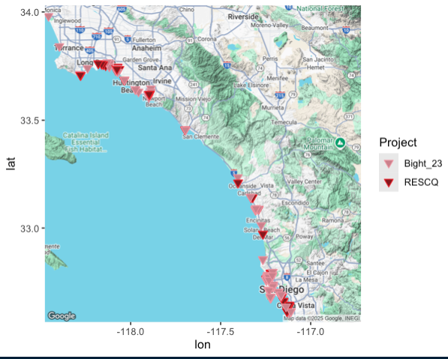

Figure A1. Map of all sites surveyed for eelgrass between Bight ‘23 and RESCQ
projects.
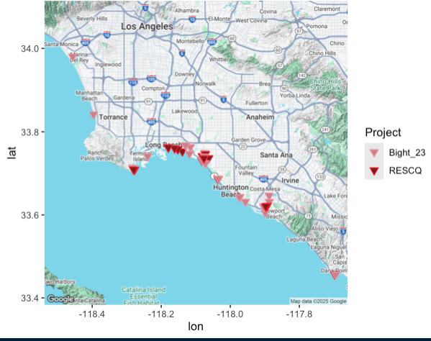
Figure A2. Map of north sites surveyed for eelgrass between Bight ’23 and RESCQ projects.

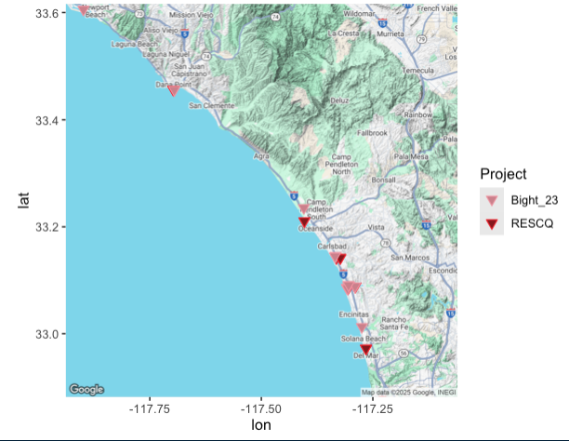
Figure A3. Map of central sites surveyed for eelgrass between Bight ’23 and RESCQ projects.
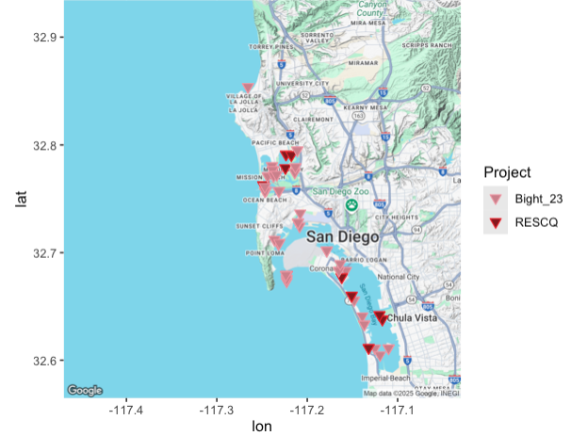
Figure A4. Map of southern sites surveyed for eelgrass between Bight ’23 and RESCQ projects.

